# I hereby swear that the work done on this homework is totally my own; and on my honor, I have neither given nor received any unauthorized and/or inappropriate assistance for this homework. I understand that by the school code, violation of these principles will lead to a zero grade and is subject to harsh discipline issues.

Cem Anaral 150119761

# SQL Queries

## a)

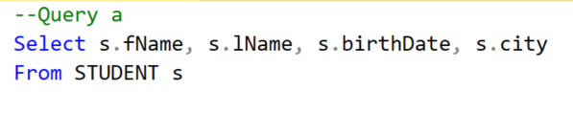

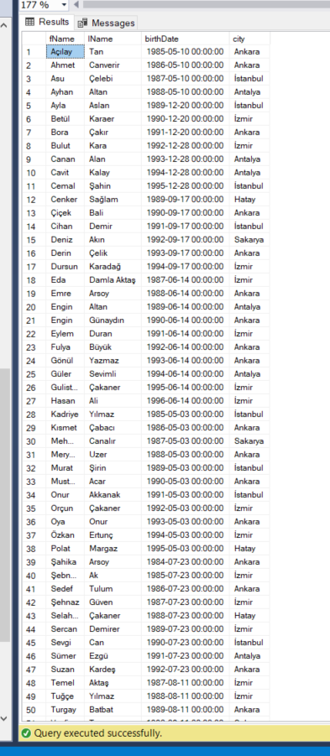

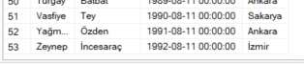

## b)

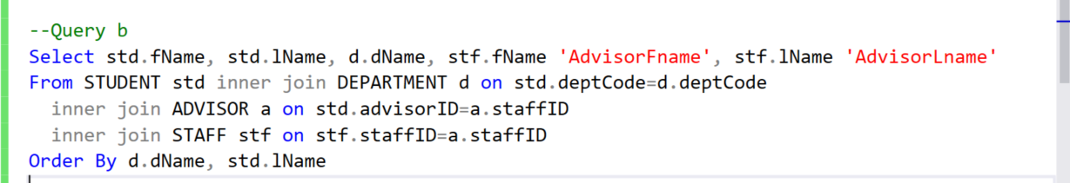

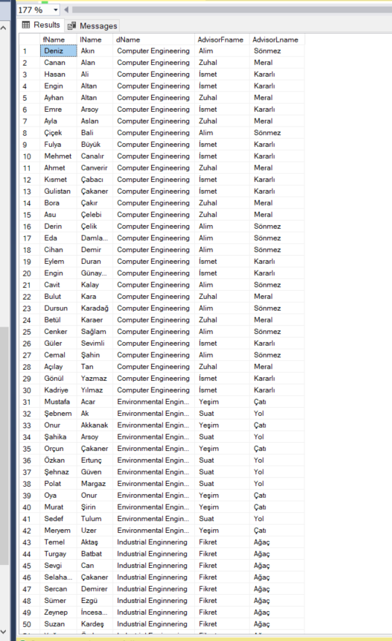

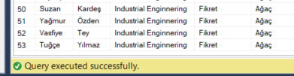

## c)

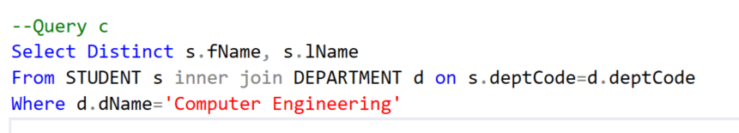

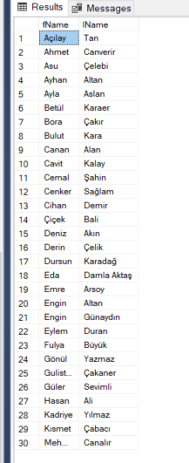

## d)

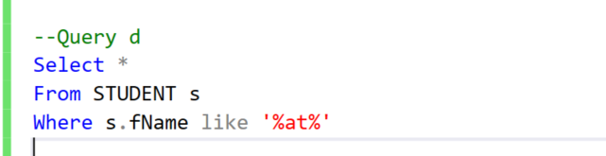

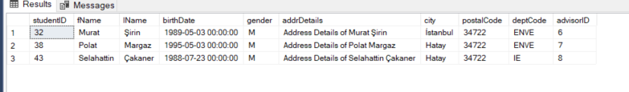

## e)

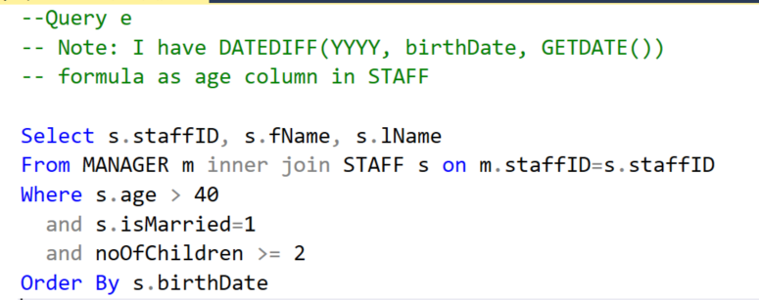

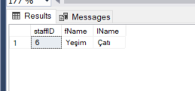

## f)

